Ideation Phase
Brainstorm & Idea Prioritization Template

Date | 20 February2026
Team ID | LTVIP2026TMIDS40712
Project Name | Exploratory-Analysis-Of-RainFall-Data-In-India-For-Agriculture
Maximum Marks | 4 Marks

Brainstorm & Idea Prioritization Template:
Brainstorming provides a free and open environment that encourages everyone within a team to participate in the creative thinking process that leads to problem solving. Prioritizing volume over value, out-of-the-box ideas are welcome and built upon, and all participants are encouraged to collaborate, helping each other develop a rich amount of creative solutions.
Use this template in your own brainstorming sessions so your team can unleash their imagination and start shaping concepts even if you're not sitting in the same room.
Reference: https://www.mural.co/templates/brainstorm-and-idea-prioritization
Step-1: Team Gathering, Collaboration and Select the Problem Statement
👥 Team Gathering
The team members assembled to discuss the project topic and understand the overall objective of the assignment. Each member actively participated in the discussion and shared their views regarding current issues in agriculture and rainfall prediction.
Team Members:
1 Bopparaju jyothi
2. Bannaravuri Triveni
3. Janjanam Yuvasreya Sree
4. Narendra Chala
🤝 Collaboration Process
- Discussion of Current Issues
The team discussed various agricultural challenges such as:
  - Irregular monsoons
  - Crop losses due to floods or drought
  - Lack of accurate rainfall prediction
  - Farmer decision-making difficulties
- Sharing Individual Ideas
Each member contributed ideas such as:
  - Analysis of past 10 years rainfall data
  - Use of farming apps
  - Greenhouse farming
  - Soil fertility improvement
  - Weather forecasting models
- Evaluation of Ideas
The team analyzed which idea:
  - Has real-world importance
  - Can be supported with data
  - Is suitable for exploratory analysis
  - Can help farmers practically

🌧️ Problem Statement
India is an agricultural country where economic growth largely depends on monsoon rainfall. Irregular rainfall patterns, such as insufficient rainfall or heavy floods, can severely affect crop production, farmer livelihoods, and overall agricultural growth.
Weather conditions have been changing over time, making rainfall prediction more challenging and important. Poor monsoons may lead to crop destruction, financial losses for farmers, and economic instability. On the other hand, accurate rainfall forecasting can help farmers plan farming activities, irrigation, and sowing decisions effectively.

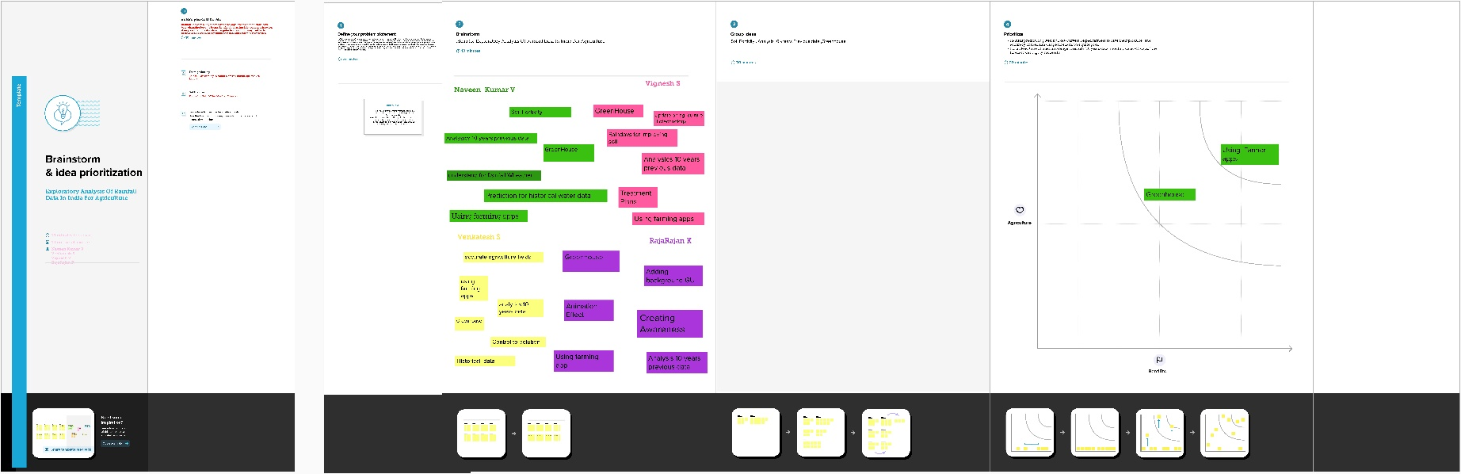
Step-2: Brainstorm, Idea Listing and Grouping

Step-3: Idea Prioritization
